**KanApp**

User’s Manual

Table of Contents

INTRODUCTION TO KanApp 3

About this manual 3

USING KanApp 4

Login and Register 4

Login Page 4

Register Page 5

Board 6

The Board 6

The Navigation 7

Task 8

Edit Project 10

# INTRODUCTION TO KanApp

## About this manual

KanApp is the websites about tool for KanBan Board which is used in Agile Software Developing method.

KanApp is product of school project in Lahti University of Applied Sciences (LAMK) in Lahti, Finland.

KanApp have these listed functions Task management, Project management and Analytics work process by Charts.

It help project team member to track the working process and for the project managers to maintain the project in the way it should be.

# 

# USING KanApp

## Login and Register

### Login Page

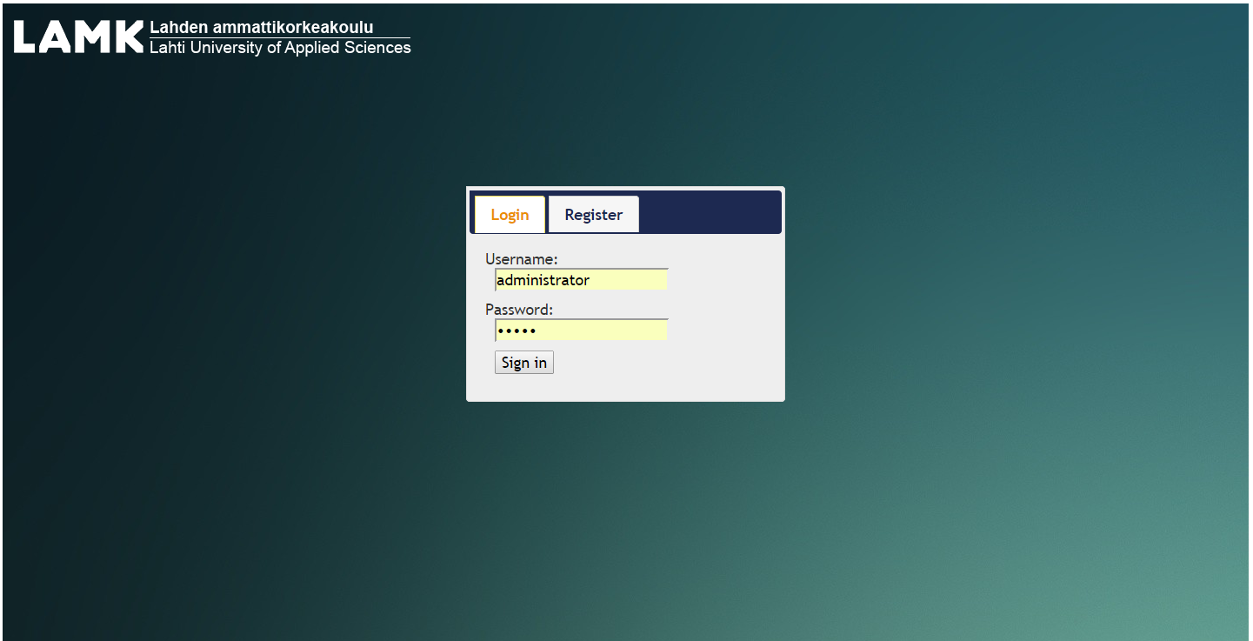

Fill in “username” and “password” field then “Sign in” to Login

### Register Page

Fill in “Username”, “Password”,”Confirm Password”, “Email”, “Security Question”, “Answer” fields then click “Register” Button.

“Confirm Password” field is used to confirm the “Password” field so it must be matched or it will show errors.

“Email” field have to fill the email format or it will show error.

## Board

### The Board

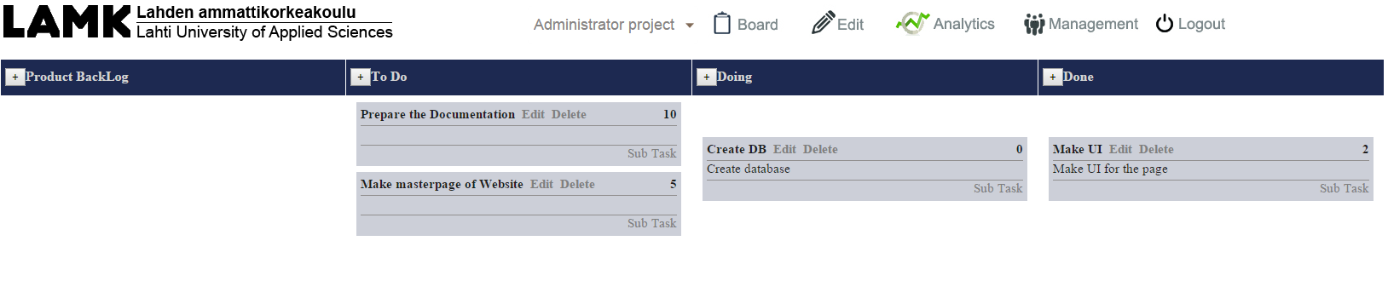

### The Navigation

Link the the school’s website

Back to Login Page

Go to Analytic Page

Go to Board Page

List of project



Go to Management Page

Go to Edit Page

The Navigation is Master Page of web-pages to help navigate to the page you want.

Board Page for the board of current project you are working on.

Edit Page for editing project you are working on.

Analytic page for seeing the charts of all projects.

Management Page for managing all the projects.

### Task

Swimlane

Swimlane name

#### Create task

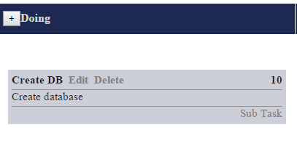

Click the button will appear the pop up window to create new task

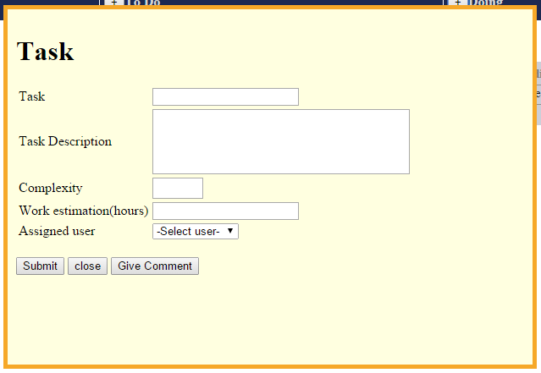

Fill in all the form to create the new task.

Complexity field must be the number

#### Edit Task

When click the “Edit”, the Popup will showed up to edit project detail

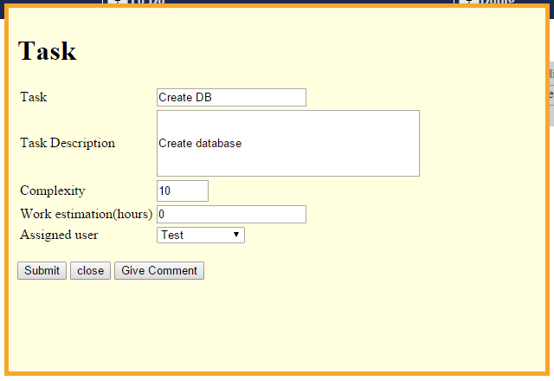

You can edit the Task details such as Name, Description, Work estimation, Assign user.

#### Task

Complexity of Task

Delete Task

Edit-Popup

Name of the Task

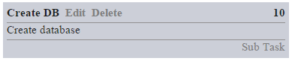

Sub-Task

Task Description

## Edit Project page

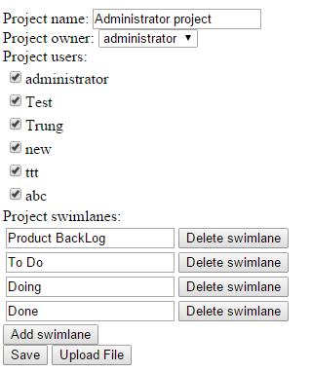

Select the Project Owner

Edit Project name

Add the swimlane name

Edit the swimlane name or delete swimlane

Select users of this project

## Analytic page

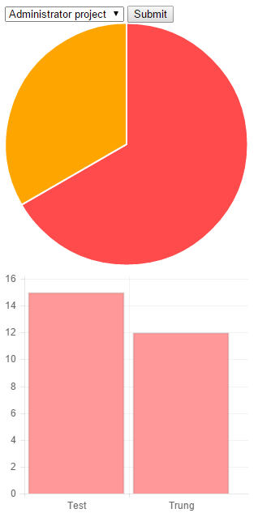

Burn-down Chart to show the complexity of task you did

Select the Project you want to see the Chart

Pie Chart to show how many task you are working on

## Management page

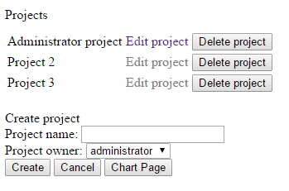

Create the new project with project name and the owner

Go to Edit page of that project or Delete project.